***ANNOUNCEMENT AND CALL FOR PAPERS***

**7th Triennial Special Issue of the IEEE Transactions on Plasma Science**

**IMAGES IN PLASMA SCIENCE (August 2014)**

Visualization of experimental and computed data is an increasingly important aspect of plasma science. Compelling images convey vast amounts of information and are often works of art in their own right. In acknowledgment of the importance of imagery, the IEEE Transactions on Plasma Science (TPS) is soliciting submissions for the *7th Triennial Special Issue* of **“IMAGES IN PLASMA SCIENCE”** to be published August 2014. This issue will present unique experimentally or computationally generated images of plasma phenomena which provide insights into the physics of the process and which are aesthetically pleasing. Examples of images include, but are not restricted to:

* Multidimensional diagnostic data
* Complex charged particle fluxes
* Streamers
* Flashover in pulsed power plasmas
* Plasma induced emission
* E-beam or ion-beam propagation
* Electromagnetic fields in plasmas
* Plasma-surface interactions
* “Naturally” occurring plasmas
* Laser propagation through plasmas
* Fusion reactor concepts
* Electron-atom or -molecule interactions
* Plasma explosive behavior

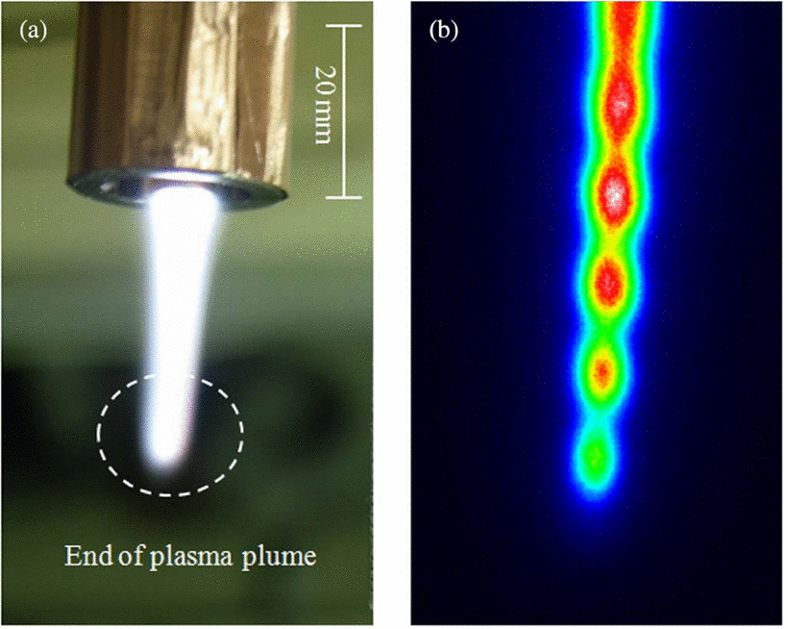

Ref: S. Kang, A. Mohamed, H. Lee, J. Lee, Trans. Plasma Science **39,** 2318 (2011).

The published articles will be limited to **2 journal pages**. The ideal paper consists of a single full-page-sized image and 1 page of text. Carefully layout your paper to ensure that the images and text are well displayed within the 2-page limit. The text should describe the physics portrayed by the image and how the image was generated (i.e., description of the model or experiment, method of generating the image). To aid with your planning, Microsoft Word templates of the 2-page layout can be obtained from the website listed below. Initial submission requires only a PDF file of the 2-page formatted version of your article. The standard manuscript format and high quality version of the image(s) will be required only when the manuscript is accepted for publication in TPS. For final submission a resolution of **at least 300 dpi** for imagesis required. If color images will lose their integrity when printed in B/W, authors are strongly encouraged to have their images printed in color in the print version of the issue (additional page charges will apply). We also require six recommended reviewers. To limit the number of papers appearing in the special issue, only the first **300 submissions** will be considered. A maximum of 3 submissions will be allowed from any given research group. To avoid duplicate publications, all submissions to the special issue will undergo an automatic plagiarism check.

**The timeframe for submissions is from** **1 November to 15 December 2013**. Contributions must be submitted in electronic form through the IEEE website as described in the **Submission instructions**.

**This announcement and templates: http://uigelz.eecs.umich.edu/tps-images/index.html**

**Submission instructions: http://uigelz.eecs.umich.edu/tps-images/submission-instructions.html**

Please direct questions to the Lead Co-Guest Editor: Ankur Agarwal (Applied Materials Inc.) ankur_agarwal@amat.com. Co-Guest Edtiors: XinPei Lu (HuaZhong University of Science & Technology) luxinpei@hust.edu.cn; Mohan Sankaran (Case Western Reserve University) mohan@case.edu; Don Shiffler (Air Force Research Lab.) don.shiffler@ieee.org; William White (Air Force Research Lab.) wmwhite@ieee.org.